**EX-5518 Physical Pendulum**

1. Physical Pendulum - Period

**Equipment**

INCLUDED:

|  |  |  |
| --- | --- | --- |
| 1 | Large Rod Stand | ME-8735 |
| 1 | 45 cm Long Steel Rod | ME-8736 |
| 1 | Physical Pendulum Set | ME-9833 |
| 1 | Rotary Motion Sensor | PS-2120 |
| 1 | 550 Universal Interface | UI-5001 |
| 1 | PASCO Capstone | UI-5400 |

**Introduction**

This experiment explores the dependence of the period of a physical pendulum (a uniform bar) on the distance between the pivot point and the center of mass of the physical pendulum.

Think about the two extremes:

1. When the pendulum is pivoting about the end, do you expect that the period is longer or shorter than if it is pivoting about the first hole down?

2. When the pendulum is pivoting about the center of the rod, what will the period be?

Since the period starts to get less as the pivot is moved toward the center, but the period is infinitely long at the center, there should be a place where the period is a minimum. You will apply simple calculus to find the minimum period.

You will also develop a mathematical model for the system and compare to theory.  By designing a free parameter (the length of the bar) into the model, the length of the bar can be accurately inferred, showing some of the power of computer models.

**Theory**

The period of a physical pendulum is given by

(1)

for small amplitude oscillations (the error is less than 1% at 20o ,it would be better at 5o). is the rotational inertia of the pendulum about the pivot point, is the total mass of the pendulum, and is the distance from the pivot to the center of mass. A uniform rectangular bar has a rotational inertia about its center of mass given by

(2)

where is the mass, is the length and is the width of the bar. For the 28-cm Pendulum Bar ( /)2 < 0.003 and we can simplify this expression to

(3)

with an error of only 0.3%.

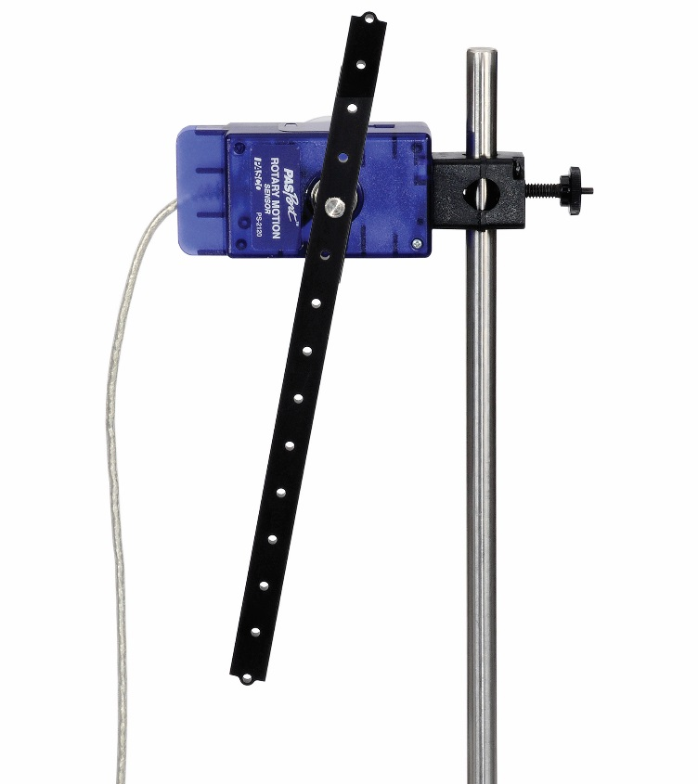

**x**

Pivot Point

Center of Mass

The parallel axis theorem enables us to write the rotational inertia of the bar about a pivot point a distance from the center of gravity as

(4)

and Equation (1) becomes

(5)

Use calculus to find the derivative of the period, , with respect to , and set it equal to 0 to find the value of that will produce the minimum period.

*Figure 1: Pendulum Setup*

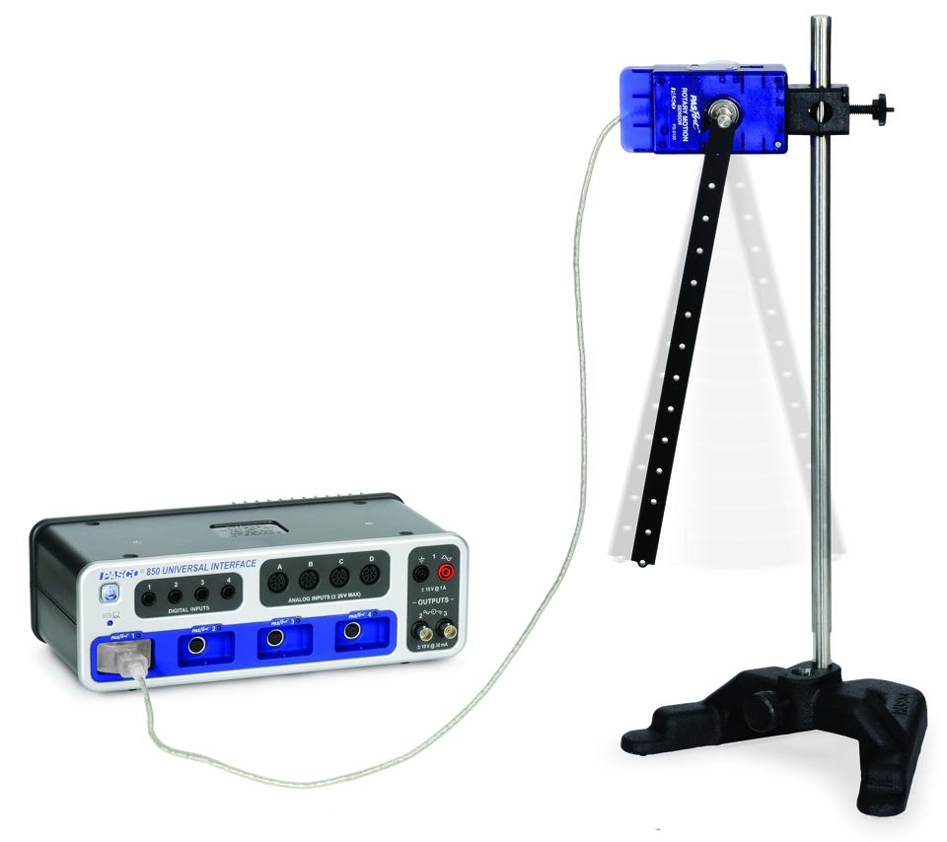

*Figure 2: Pendulum Setup*

**Setup**

1. Using a meter stick, measure the length of the Pendulum Bar (ignore the small tabs on the ends) and the distance between holes.
2. Put the Rotary Motion Sensor on the rod stand and plug it into the Universal Interface 850. See Figure 2.
3. Use the mounting screw to attach the Pendulum Bar to the Rotary Motion Sensor using the hole that is the end of the rod.

**Procedure**

1. In PASCO Capstone, create a graph of Angle vs. Time.
2. Displace the pendulum by less than 20o (0.35 rad) (it would be better around 5o) from equilibrium and release it. Click on Record.
3. Click STOP after about 15 seconds.
4. Move the mounting screw to the next hole down from the end and repeat.
5. Repeat using the each of the holes until you reach the center.

**Analysis**

1. Find the period of oscillation for each position of the pivot.
   1. Select Run #1 on the graph.
   2. Click the Coordinates Tool button in the toolbar. Move the Coordinates Tool to one of the first peaks of Angular Position.
   3. Right-click on the Coordinates Tool and turn on the Delta Tool. Measure the period by measuring the time for 10 periods and divide by 10.
   4. In the table, enter the period you measured in the T column beside the zero in the distance column.
   5. Repeat for each of the seven runs.
2. Determine which distance gives the minimum period of oscillation of the pendulum bar and compare to what you calculated in the theory section.

**Theoretical Curve Fit**

1. Apply a User-Defined fit to the data on a Period vs. Distance graph. Use Equation (5) and lock in the appropriate numbers in the Curve Fit Editor.
2. How well does the theoretical curve fit your data? Does the curve fit better for some of the points than others? Does making a selection of only some of the points make the curve fit better?
3. Unlock the parameter which depends on the length of the pendulum. Update the fit and calculate the length of the pendulum from the new parameter value. What length does this give? How close is it to the actual length of the pendulum?

**Questions**

1. What is the percent difference between the calculated value for the length that gives minimum period of oscillation and the measured value for the length?
2. Would a pendulum bar with different mass but with the same dimensions have a different value for the length that gives minimum period of oscillation? Why or why not?

2. Rotational Inertia Based on Period of Oscillation

Equipment

INCLUDED:

|  |  |  |
| --- | --- | --- |
| 1 | Large Rod Stand | ME-8735 |
| 1 | 45 cm Long Steel Rod | ME-8736 |
| 1 | Physical Pendulum Set | ME-9833 |
| 1 | Clamp-on Pulley | ME-9448B |
| 1 | Rotary Motion Sensor | PS-2120 |
| NOT INCLUDED, BUT REQUIRED: | | |
| 1 | 850 Universal Interface | UI-5000 |
| 1 | PASCO Capstone | UI-5400 |

Introduction

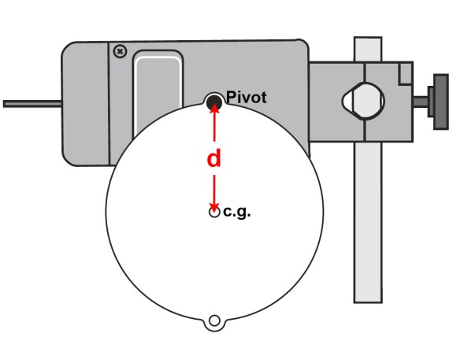The period of oscillation of a physical pendulum will be measured and used to calculate the rotational inertia of the pendulum. The rotational inertia is also determined by measuring the mass and the dimensions of the pendulum.

*Figure 1. Pivot and center of gravity of the disk pendulum*

**Theory**

The period of oscillation,, of a physical pendulum depends on the rotational inertia about a pivot point,, the mass, , and the distance from the pivot point to the center of gravity, .

(1)

The Parallel Axis Theorem states that the rotational inertia about a pivot point, , is equal to the sum of the rotational inertia about the center of mass,, and the rotational inertia of the object as if all its mass was at the center of mass:

(2)

Conversely, the rotational inertia about the center of gravity could be found as follows:

(3)

where

(4)

Therefore, the rotational inertia about the center of gravity is

(5)

**Part I:** Finding Rotational Inertia by Measuring the Period of Oscillation

**Setup**

1. Measure and record the mass M, of the disk.
2. Measure and record the distance, d, from the pivot point on the edge of the disk to the center of the disk.
3. Mount the Rotary Motion Sensor on a support rod so that the shaft of the sensor is horizontal (parallel to the table).
4. Use a mounting screw to attach the disk to the shaft of the sensor through a hole on the edge of the disk.
5. Connect the Rotary Motion Sensor to the interface.
6. Set up a Graph display of Angle (rad) versus time (s).
7. Increase the sampling rate to 100 Hz.
8. Open the Calculator and make a calculation:

T=period(10,10,1,[angularvelocity(rad/s), ▼])

1. Create a graph of Period (T) versus time. In the ‘Statistics’ menu of the graph, select Mean. Click the ‘Statistics’ button in the toolbar to activate the statistics.

**Procedure**

1. Gently start the disk swinging with a small amplitude (about 20 degrees total, 5 degrees would be better).
2. Click ‘Record’ to begin recording data. After about 25 seconds, click ‘Stop’ to stop recording data.
3. Repeat the process for several more trials. Determine the average of the values of the period of oscillation and record the average value in the table.

**Analysis**

1. Using Equation (5), calculate the rotational inertia about the center of gravity using the period, , the mass, , and the distance from the pivot point to the center of gravity, .
2. Record the calculated value for the rotational inertia in a table.

**Part II:** Finding Rotational Inertia by Measuring the Dimensions and Mass

**Theory**

The theoretical rotational inertia of a disk (radius and mass ) about its center of mass given by

(6)

**Procedure**

1. Measure the diameter and the mass of the disk.
2. Calculate the rotational inertia of the disk about its center of mass.

**Questions**

1. Determine the percent difference between the rotational inertia calculated from the period and the rotational inertia calculated using the dimensions.
2. Do your results support or disprove the idea that the rotational inertia of a physical pendulum can be determined from its period of oscillation. Why or why not?

**Extensions**

Repeat the procedure for the thin ring, thick ring, and offset hole, each pivoting about the outside edge. For the offset hole, solve for the rotational inertia about the pivot, rather than about the center of mass. To find for this object, balance the disk flat on the edge of a table and make a small pencil mark at the center of mass (where the edge of the table is when the disk is balanced).

1. Rotational Inertia Based on Angular Acceleration

For the irregular shape, it is not possible to find the rotational inertia from the dimensions. However, it can be found by accelerating it with a known torque.

To find the rotational inertia of the irregular shape experimentally, a known torque is applied to the irregular shape, and the resulting angular acceleration, , is measured. Since ,

(3)

where is the torque caused by the weight hanging from the string which is wrapped around the large step of the 3-step pulley of the apparatus.

(4)

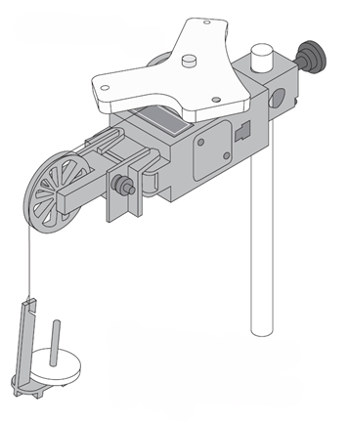

**a**

F

mg

*Figure 3. Free-body Diagram*

where is the radius of the pulley about which the string is wound and is the tension in the string when the apparatus is rotating. Also, , where is the linear acceleration of the string.

Applying Newton's Second Law for the hanging mass, , gives (See Figure 2)

(5)

solving for the tension in the string gives

(6)

Once the linear acceleration of the mass () is determined, the torque and the angular acceleration can be obtained for the calculation of the rotational inertia.

Finding the Acceleration

(a) Mount the irregular shape on the Rotary Motion Sensor using the center hole. To find the acceleration, put about 10 g over the pulley and record the angular velocity versus time on a graph as the mass falls to the table.

(b) Use the linear curve fit on the graph to find the straight line that best fits the data. Use the mouse to select the part of the graph where the mass was falling, so the line will be fitted only to this part of the data.

(c) The slope of the best-fit line is the angular acceleration of the apparatus. Record this acceleration.

Use the acceleration to determine the rotational inertia of the irregular shape.

Appendix: Rotational Inertia Equations

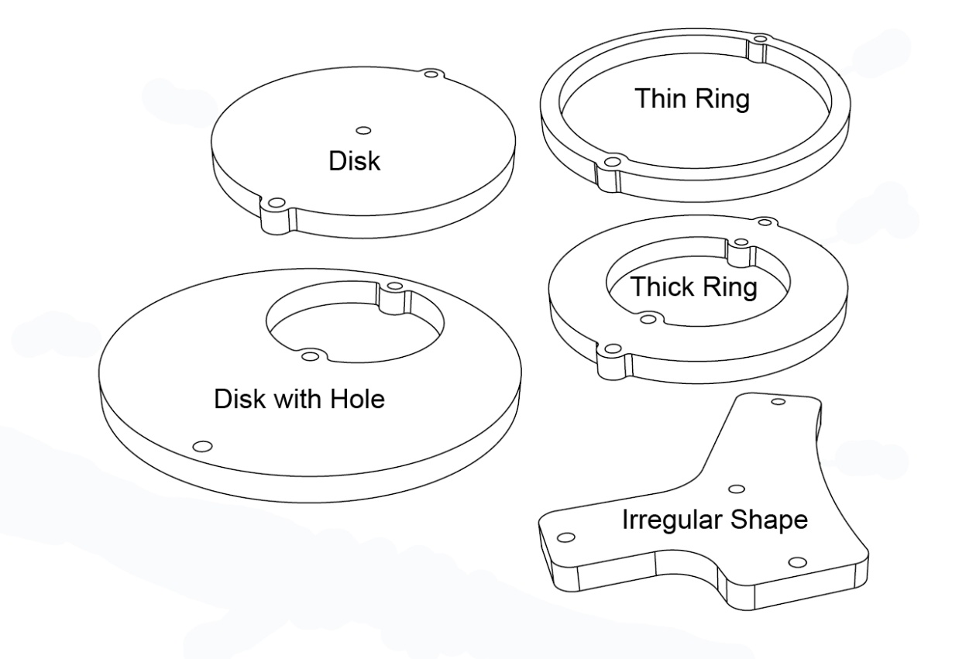

For a disk about its center of mass: (6)

For a thick ring about its center of mass: (7)

For a thin ring about its center of mass: (8)

For a disk of radius with a hole of radius , pivoting at the outer edge of the hole:

=distance from pivot to center of disk (9)